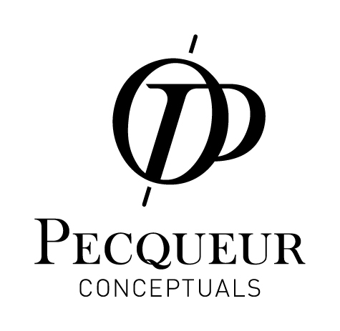

INTERVIEW 1: “WATCH DESIGN DEVELOPMENT PHASES”
Interviewees: Cathal Loughnane (Peugeot Design Lab); Jean-Philippe Coulaud (Noosphaire).
Introduction (Bogdan Kowal): Good morning sirs, you’ve partnered in this adventure which consists of launching a new brand. The first product that this new brand will unveil is a watch. The development approach, just like the product itself, is somewhat different. We’d like to know a bit more, whether it’s about the design with Peugeot Design Lab or the communication with Noosphaire.
Q1 (Cathal): Cathal Loughnane, what drove you to collaborate with Noosphaire on the design of a watch launched by a totally new brand?
A: Peugeot Design Lab is a Global Brand Design studio. When Noosphaire contacted us not only to design a watch but also to participate in defining the overall environment of the Pecqueur Conceptuals brand, we thought it was an interesting opportunity and an exciting challenge to take up.
Moreover, I believe that a designer is 50% performer and 50% engineer. The Pecqueur Conceptuals signature: “Mechanical Arts in Motion”, which clearly asserts the brand positioning, is a philosophy that resonates with who we are, as automobile designers.
Q2 (JP): Jean-Philippe Coulaud, tell us about the specifics mentioned by Cathal Loughnane in the distinctive positioning of Pecqueur Conceptuals.
A: Simultaneously inspired and fascinated by the inventive genius of Onésphore Pecqueur, our ambition for Pecqueur Conceptuals is to perpetuate this highly sophisticated innovative approach to excellence. Going far beyond words, we intend to develop new concepts through a language that celebrates technical complexity.
With regards to what Cathal says about the brand signature, it encompasses the historical legitimacy of the mechanical arts in the horological field and the new developments necessary to ensure they retain their status, on a purely technical as well as intellectual level. This is where we refer to the notion of ‘putting in motion’.
Q3 (JP): Why choose to create a watch as a first ever design product?
A: Because of the previously mentioned historical legitimacy. In the field of mechanics, watchmakers were often the precursors to developing innovative mechanisms. A few centuries ago, these mechanical artists were the first to create and assemble complex mechanical cogs, which later became known as watch complications, for the clocks and pocket watches of the time. Today, connoisseurs of sophisticated mechanisms remain fascinated by complex horological movements and the miniaturization of their components. It was for all these reasons that we wanted to start off by designing a watch. Later, however, Pecqueur Conceptuals will follow up with other objects; our intention is not to become a new watch brand.
Q4 (Cathal): Cathal, concerning the new complication developed for this watch, did your designers have a role to play in defining some of the technical features?
A : With regards to the purely technical elements of this new GMT complication, the Swiss horologists from Centagora worked according to very precise specifications set by Noosphaire, and so we had no direct involvement there. However, since the start of the project, we’ve been working very closely with Centagora on the choice and positioning of certain components and key parts that could have an influence on the design of the watch, whether on the dial or the casing.
Q5 (Cathal): Cathal, without revealing the exact design of the watch because it’s in the final stages of development, could you tell us a little about the elements that will give it a unique personality and signature ?
A:The differential is at the heart of the Pecqueur watch which has been designed to emphasise this key element. This mechanism will be integrated into a dial and a stylish, quality casing, completely in keeping with the heritage of the man who inspired the brand and codes defined in advance. A watch is an object that has a multitude of aspects and enables us to be quite subtle with the solids and voids at different levels of execution.
Q6 (JP): Jean-Philippe, what significant contribution have Peugeot Design Lab brought to this project?
A: It’s difficult to quantify because Cathal and his team have been involved in all the development phases of the project since its conception. It all started in the brainstorming sessions to define the brand codes that led to the creation of the visual identity. Then there were all the meetings and monitoring sessions with the horologists, related to the development of the movement itself, and ultimately followed by the design phase of the watch itself in which we’re currently working on.
For Pecqueur Conceptuals, the design is crucial to the conception of our watch part. It projects the brand values while transcending the aesthetic of mechanical components. This helps to hone the mechanical language that Pecqueur Conceptual aims to express. Taking into account the increasing complexity of the aspirations of potential customers, the exact positioning of a brand through the image projected by its products has become primordial. However, this demands truly distinctive substance on which to base communications and drive creativity.

